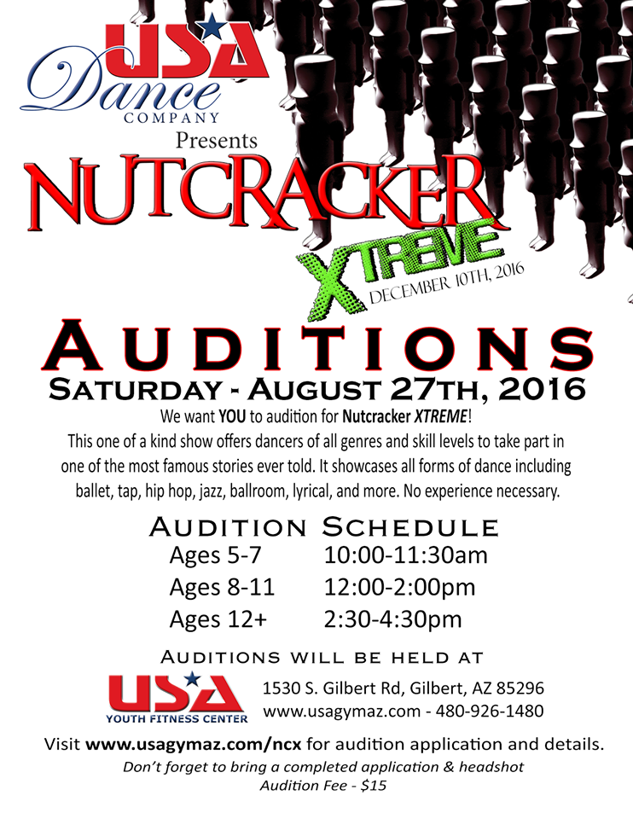
Audition Application
Please Complete the Information Below in its Entirety
Incomplete Applications will not be Accepted
Performer Full Name
Headshot Provided Y N
Parent Name
Parent Email
Parent Phone
May we text this phone? Y N
Home Address
City, State, Zip
Age /Birthdate
Male Female
Years of Dance Experience
Specialty:
Ex: Ballet, Tap, Pointe, Jazz, Hip Hop, Acro, Gymnastics, Tumbling, Musical Theater
Shirt, Pants, Shoe Size | Shirt_____________ Pants____________ Shoe_____________
Measurements at Time of Auditions ( to be done by USA Staff at auditions)
Height
Bust
Waist
Hips
Girth
Neck
Hip to Floor
Bring a Headshot Picture
with Name Printed on the Back, Stapled with your Audition Packet
*Does not have to be fancy or formal, just a headshot/picture

Participation in USA Nutcracker XTREME is a fantastic experience accompanied by responsibility and serious commitment from both the performer and parent.
- Existing USA Dancers and Athletes must be enrolled and maintain their attendance in the appropriate number of technique classes per week. Roles will be recast if a USA Athlete does not adhere to the required number of classes.
- USA Pointe dancers must maintain their attendance in the appropriate number of pointe classes per week. Roles will be recast if a dancer does not adhere to the required classes.
- There will be a Mandatory parent meeting. (Saturday 9/3 1:00 PM)
- All participating families will be asked to pay a Participation Fee (per participant) and Costume Rental Fee (per participant). Participation Fee is due at the Mandatory Parent Meeting. Costume Rental Fee due date will be announced at the Parent Meeting.
- Rehearsals:
  - Rehearsals will be held on the weekends.
  - Performers cannot be absent from more than one rehearsal. Any performer who is absent more than allotted may be dismissed and their role, recast.
  - Any performer missing after November 1st may be dismissed from their role and recast.
  - Performers may be asked to participate in publicity photos and fundraising activities.
Rehearsals Begin: September 10th
Cast Photo: November (Date and Time TBA)
Performance: December 10th
Skyline High School
845 S Crismon Rd Mesa, AZ 85208
Dress Rehearsal on Thursday (IN STUDIO)
Friday Evening & Saturday Morning (AT SKYLINE). Times TBA
Performance Begins at 6:30 PM

________________________________________
Performer Name

All performers are required to attend all rehearsals that they are scheduled for. If a rehearsal is missed due to a non-emergency (see theatre rules and regulations), the director reserves the right to re-cast another actor in the role. If you have any Possible conflicts with the rehearsal schedule (ANY SATURDAY) please list them here:

Date | Reason

