

WELCOME TO USA XTREME Dance Company

The USA DANCE Program puts athletes in a position to excel while instilling work ethic, accountability and community spirit. USA is one of the largest gyms in Arizona with three facilities and over 175 staff in total. USA offers Dance for every age from Tiny Novice to a pre-professional Team. We have Dance Rec Classes at both our Gilbert and Queen Creek locations.
Our “XTREME” Competitive and “Stars & Stripes” Performance Teams are composed of novice dancers through advanced dancers aged 5 to 18. Our teams are formed based on the talent we see at tryouts. We accept male and female dancers across all levels.
Our motto is: Friends, Teammates, Family…for Life!

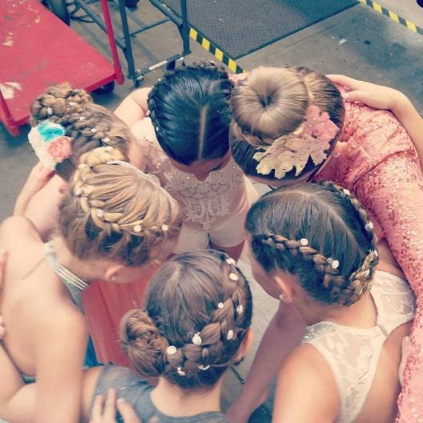

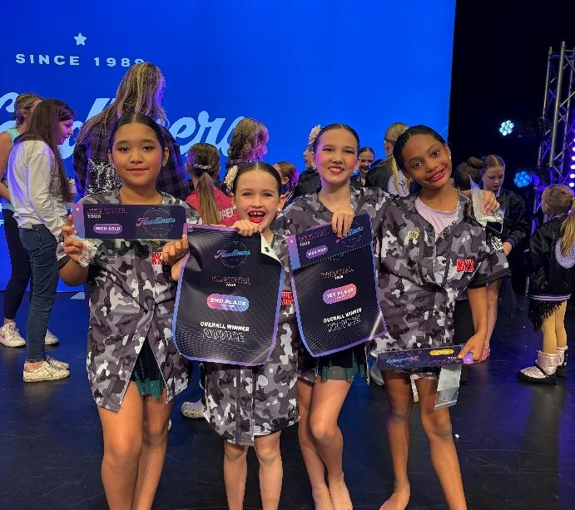

AUDITIONS
2 STEP Audition REGISTRATION PROCESS:
Step One: Create an account in iClass through our website at www.usagymaz.com. Sign up for the XTREME Dance Company Audition at our Gilbert location in iClass. The fee is $20 for returning athletes and $30 for new athletes. If you have any questions, please contact our office at (480) 926-1480.
Step Two: Download the Audition Packet from the website. Fill out pages 12-14. Bring the completed forms to the office before Auditions.

AUDITIONS:
Gilbert: May 16th Gilbert: June 20th (Makeup Audition)
Ages 5-7: 12:00-1:00 pm
Ages 8-11: 1:00-2:00 pm
Ages 12 +: 2:00-4:00 pm

WHAT TO EXPECT AT AUDITIONS:
- Check in at the sign-in table and receive a name tag.
- Wait outside Studio 3 to be called in by staff.
- Bring all dance shoes and water in with you.
- Dancers will warm up and be evaluated.
- Auditions are run like a dance class. No need to prepare anything.
- Dancers wear form fitting dance attire & hair in a slicked-back ponytail or bun.

ANNOUNCEMENTS & NOTIFICATIONS:
Download the “Stack Team App” to receive audition updates and other important announcements and notifications. Please follow the steps below.
Download the App-> Create an account (First and Last Name required)-> Join-USADC XTREME USA Dance Company->Request access Group “2026-2027 Auditions”.
Look for updates and notifications! Clicking the little bell icon at the bottom corner will show you all Notifications. Please ensure you enable and allow the Stack Team App to send you notifications.

2026 – 2027 DATES
IMPORTANT DATES:
MAY 16: AUDITION #1
JUNE 15: SUMMER SCHEDULE BEGINS
JUNE 20: AUDITION #2
JULY 1: NON-REFUNDABLE DEPOSIT OF $500 DUE
JULY 6–30TH: SUMMER DANCE CAMPS
JULY 23-30: PRODUCTION CHOREOGRAPHY
AUG-NOV: GROUP ROUTINE CHOREOGRAPHY
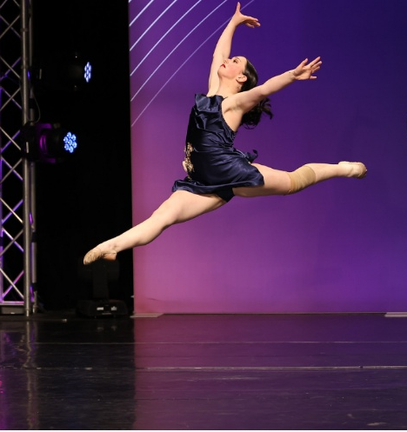
NOV 23: “BE THANKFUL” IMPROV SHOWCASE
DEC TBA: HOLIDAY SHOWCASE

GYM CLOSURES:
MAY 25-29: MEMORIAL DAY BREAK
JUN 29-JUL 4: JULY 4 BREAK
OCT 5-9: FALL BREAK
OCT 31: HALLOWEEN
NOV 25-27: THANKSGIVING BREAK
DEC 21-JAN 1: HOLIDAY BREAK
The 2026-2027 Competition Schedule will be posted in AUGUST.

ALL SEASONAL FEES and the initial $500 deposit are non-refundable. If a team member does not complete the season after joining the team, these fees will not be refunded.

Additional Questions? Contact us at tina@usagymaz.com.

USA Dance Company PROGRAMS
USA DANCE COMPANY “REC PROGRAM”
USA Dance Company Recreational program is the foundation for all our programs. This is where your dancer will find their love of dance and begin building technical and performance skills. Whether they take classes just for fun, or decide dance is their passion, dancers will enjoy getting to learn and grow their dance skills. We welcome dancers aged 2-18 to experience our enthusiastic coaching staff. We take the time to find what style of dance brings them the most joy! We are here to help your child develop a true passion for dance! All Recreational dance classes are invited to participate in two Showcases per year: our annual Christmas Showcase and June Recital.
USA DANCE COMPANY “STARS & STRIPES” PERFORMANCE TEAM
USA Dance Company Stars & Stripes Performance Team is the next step for the enthusiastic dancer that loves to perform! This program is intended for dancers that find themselves wanting more performance opportunities. These Dancers are included in our bi-annual showcases, perform in local parades such as the Chandler Parade of Lights and the Gilbert Days Parade, and participate in other community performances including one competition hosted in the spring.
USA XTREME DANCE COMPANY
USA XTREME Dance Company is a competitive dance team comprised of dancers who want to be trained at a pre-professional level. Age consideration for the EXTEME Dance Company begins at five years old. Dancers are required to participate in multiple classes/styles to create technically sound, well-rounded, and confident performing dancers. Dancers in this group gain necessary skills to grow and develop their dancing abilities fostering lasting bonds with their teammates and instructors, These Dancers compete in three or more Dance Competitions and perform locally many times throughout the year.

We pride ourselves in being able to create athletic, competitive, and technical dancers. We infuse the best part of all of this into the dancing we do…the Artistry… Story telling…and Emotional Connection.

Whether you decide dance is a lifelong choice or a childhood hobby, the benefits from being a part of something that requires dedication, discipline, along with mental/physical challenges are the building blocks towards becoming a confident, mindful, and active adults.
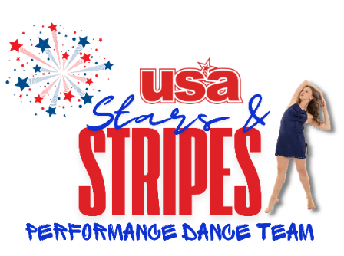
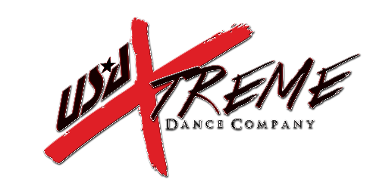


ALPHA CO. (Teen)

10+ Hours of technique classes required per week
WEEKEND Choreography IN THE FALL
3 Mandatory COMPETITIONS per Season

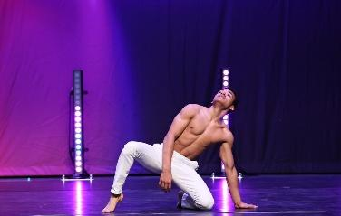
PROGRAM FEES:
Non-Refundable Team Fee: $500 Due June 20th
Tuition: $320 monthly for 12 months (June through May)
Competition Routine Fees: $500 Per Group Dance (includes all 3 Competitions)
Convention Fee: $350
Master Class/Guest Teacher Fee: $300
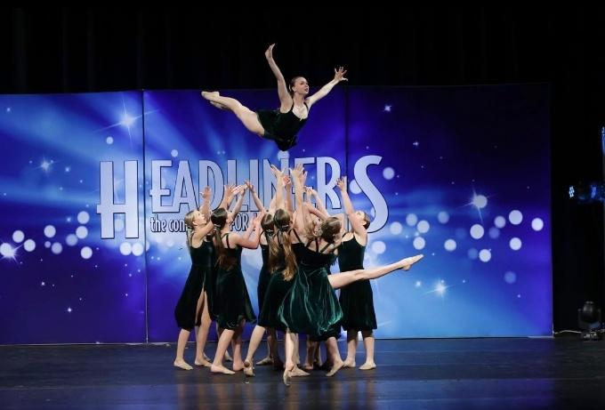
Recital/Showcase Fees: $400 (includes costumes and participation)
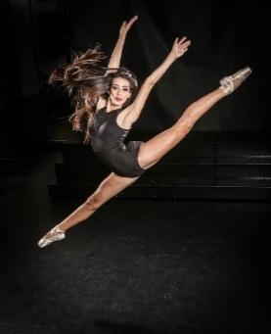
PROGRAM FEES INCLUDE:
Competition Group Costumes
Group Routine Choreography
Extra Rehearsals
Music Fees
Costume Accessories
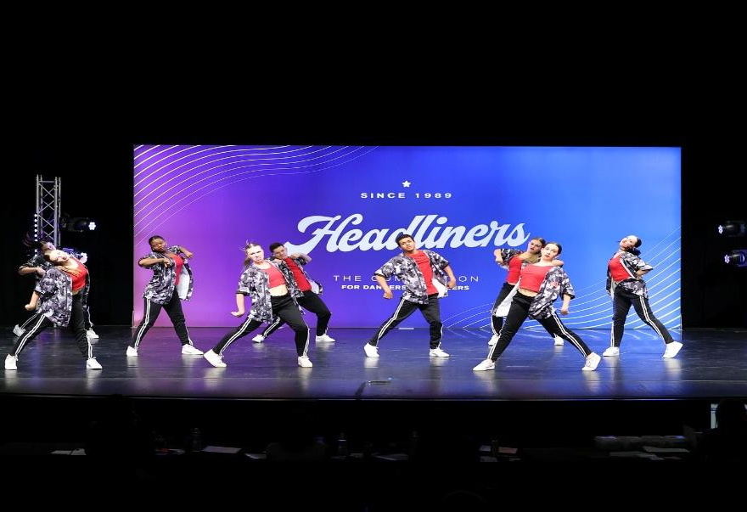
Competition Group Dance Entry Fees
Coaches Fees
NOT INCLUDED IN PROGRAM FEES:
Gym Annual Membership
Uniform/Spirit Wear/Shoes/Tights
Solo/Duo/Trio Choreography Costs
Solo/Duo/Trio Costumes/ Comp Entry Costs
Travel costs to competition
End of Season Banquet
Dancer Competition Swag Bags
BRAVO CO. (8-11 yrs)

PRACTICE: 3X A WEEK / WEEKEND PRACTICES IN THE FALL
3 MANDATORY COMPETITIONS PER SEASON

PROGRAM FEES:
Non-Refundable Team Fee: $500 Due June 20th
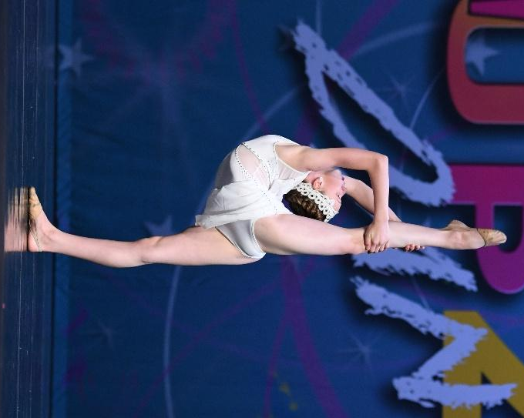
Tuition: $240 monthly for 12 months (June through May)
Competition Routine Fees: $500 Per Group Dance (includes all 3 Competitions)
Convention Fee: $350
Master Class/Guest Teacher Fee: $300
Recital/Showcase Fees: $400 (includes costumes and participation)
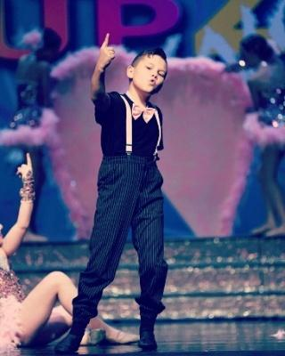
PROGRAM FEES INCLUDE:
Competition Group Costumes
Group Choreography
Extra Rehearsals
Music Fees
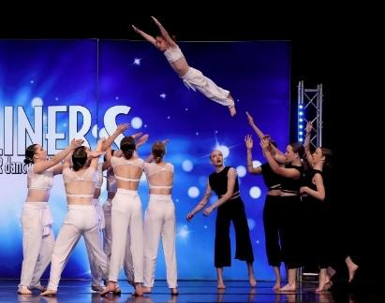
Costume Accessories
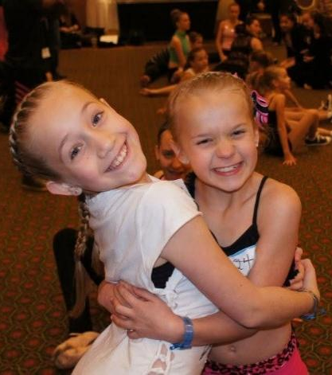
Competition Group Dance Fees
NOT INCLUDED IN PROGRAM FEES:
Gym Annual Membership
Uniform/Spirit Wear/Shoes/Tights
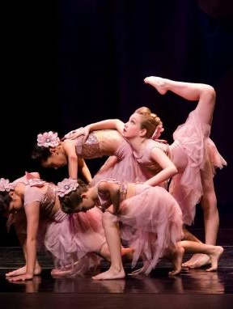
Solo/Duo/Trio Choreography Costs
Solo/Duo/Trio Costumes, Comp Entry Costs
Travel costs to competition
End of Season Banquet
Dancer Competition Swag Bags

ECHO CO. (5-7 yrs)
TECHNIQUE CLASSES 2X WEEK
WEEKEND REHEARSAL IN THE FALL
3 COMPETITIONS
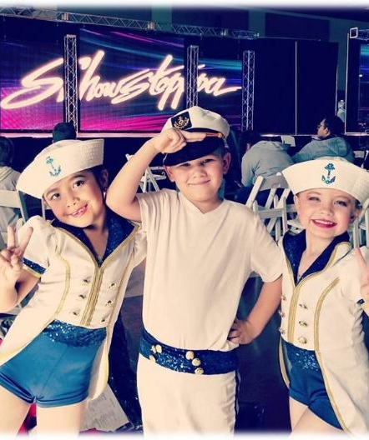
PROGRAM FEES:
Non-Refundable Team Fee: $500 Due June 20th
Tuition: $240 monthly for 12 months (June through May)
Competition Routine Fees: $500 Per Group Dance (includes all 3 Competitions)
Convention Fee: $350
Master Class/Guest Teacher Fee: $300
Recital/Showcase Fees: $400 (includes costumes and participation)
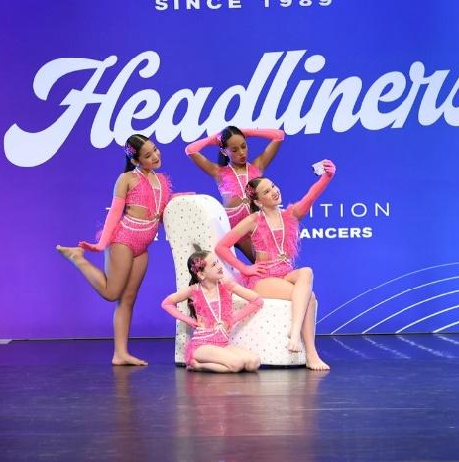
PROGRAM FEES INCLUDE:
Competition Group Costumes
Group Choreography
Extra Rehearsals/Music Fees
Costume Accessories
Competition Group Dance Fees
Coaches Fees
NOT INCLUDED IN PROGRAM FEES:
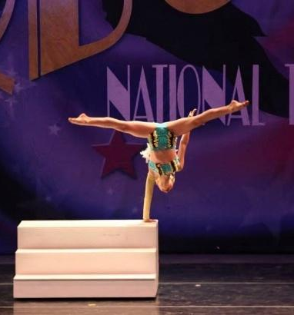
Gym Annual Membership
Uniform/Spirit Wear/Shoes/Tights
Solo/Duo/Trio Choreography Costs
Solo/Duo/Trio Costumes, Comp Entry Costs
Travel costs to competition
End of Season Banquet
Dancer Competition Swag Bags

STARS & STRIPES PERFORMANCE CO.

Technique/Choreo Classes
Practice 1-2 X Week
1 REQUIRED COMPETITION
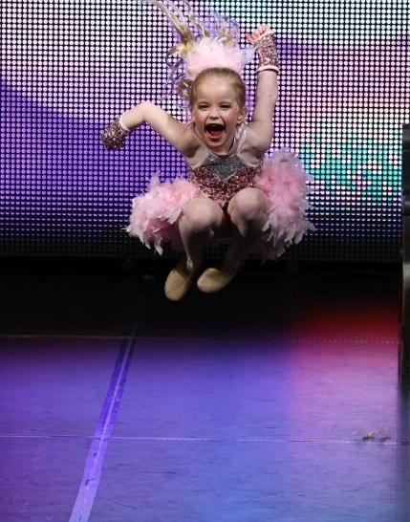
NO AUDITION REQUIRED!
PROGRAM FEES:
Non-Refundable Deposit: $100 Due on June 20th
Competition Routine Fee: $75 (One Competition)

Team Costume- $100
Recital/Showcase Fees- $200 (Includes participation fees)
Tuition: monthly for 12 months (July through June)
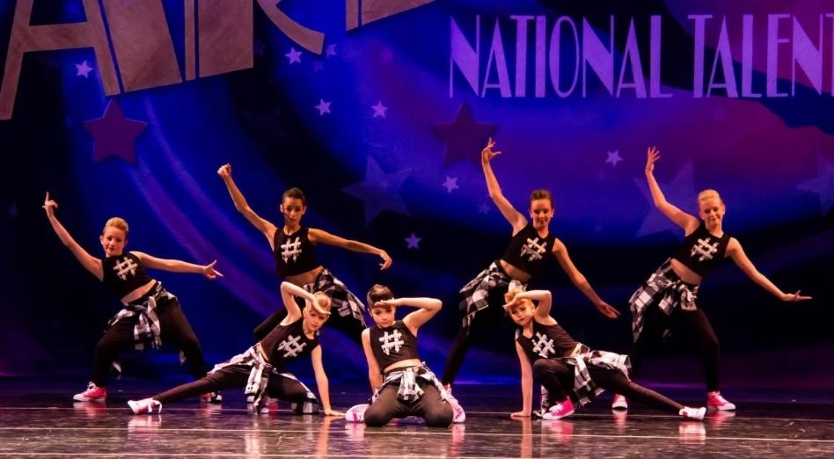
Starbursts-$90 (1 hr. wk.)
Glowettes-$175 (2 hrs. wk.)
Dazzlers-$175 (2 hrs. wk.)
PROGRAM FEES INCLUDE:
Competition Group Costume
Group Choreography
Extra Rehearsals/Music Fees
Costume Accessories

Competition Group Dance Fees
Coaches Fees
NOT INCLUDED IN PROGRAM FEES:
Gym Annual Membership
Uniform/Spirit Wear/Shoes/Tights
Travel costs to competition
End of Season Banquet
Dancer Competition Swag Bags

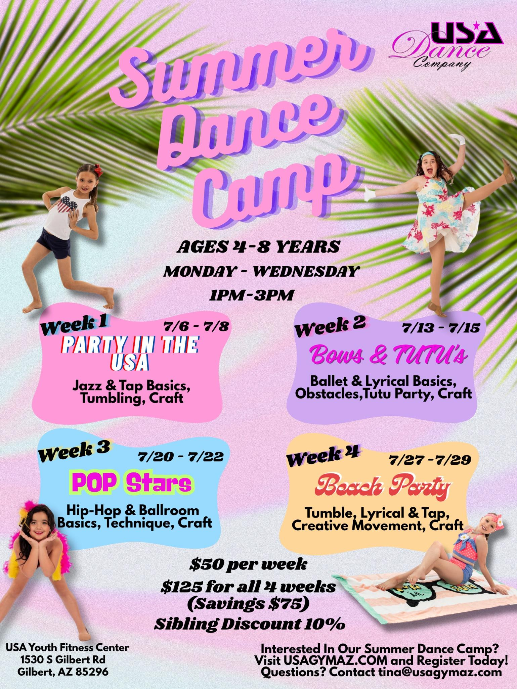
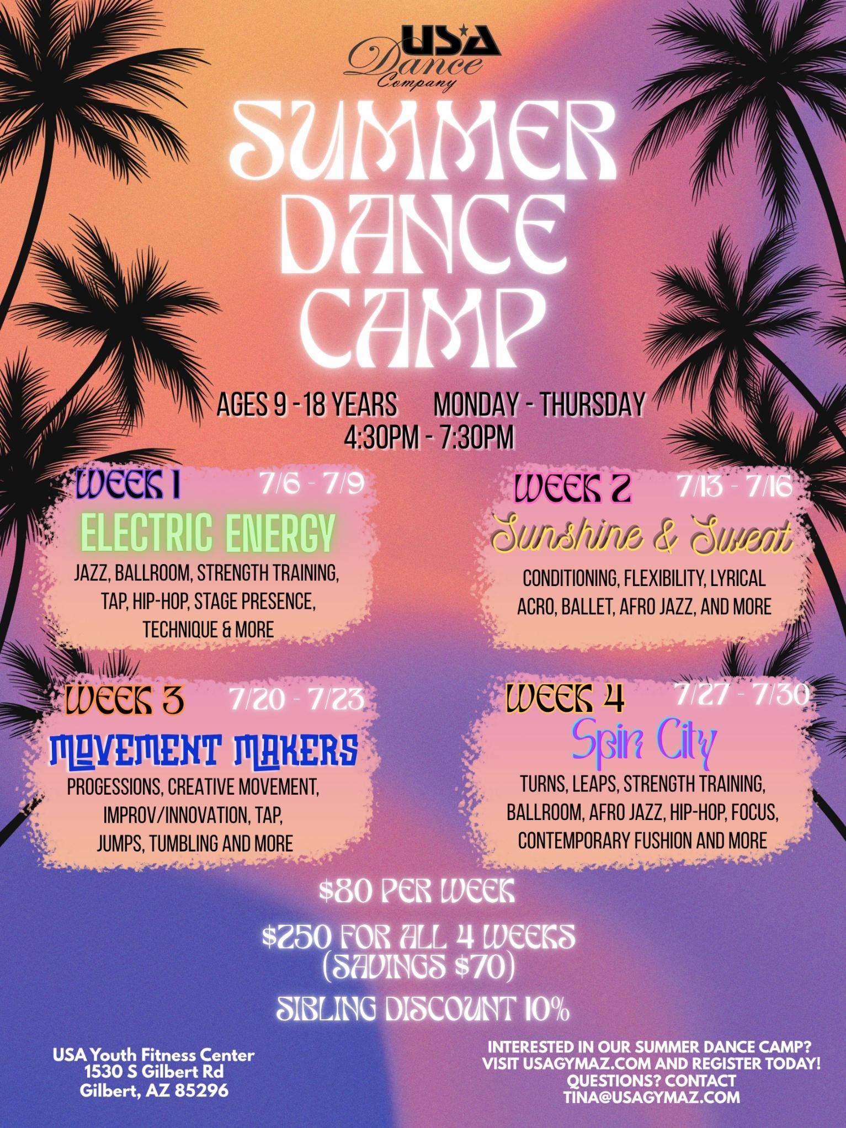

GYM INFORMATION:
USA XTREME Dance Team dancers also receive 50% off Tumbling classes and Cheer Technique/Stretch classes. Siblings of USA XTREME Dance Team Dancers receive 20% off tuition for classes in any program. Once an athlete becomes a member of the gym, you are eligible to attend open gyms, camps and other special events hosted by USA.
REFERRALS: The best advertising for USA Dance is referrals from our current parents and Dancers. We offer a generous referral program! Each team member referral receives one month of FREE tuition.
COMMITMENT: USA XTREME Dance Company is a commitment for the dancer and the dancer’s family. USA has an attendance policy that is strictly followed. Dancers are allowed 7 absences starting in August through May, including school graded events. Athletes must attend all practices, including choreography, or extra practices. Competition Dancers are not allowed to miss any days two weeks prior to a dance competition. A drop fee of $350 will be charged if an athlete quits during the season and does not attend these events.
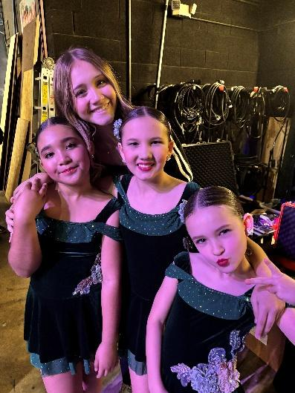
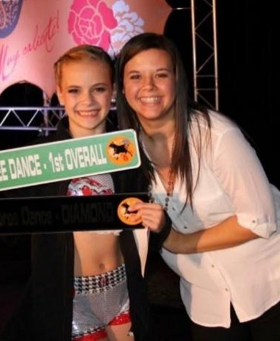
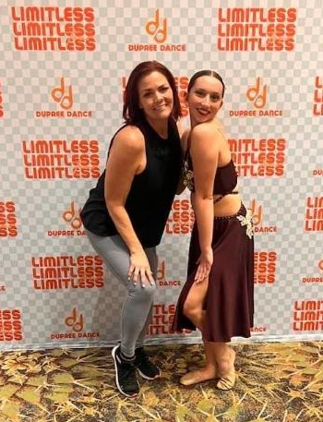


1530 S. Gilbert Rd. 24648 S. Ellsworth Rd
Gilbert, AZ 85296 Queen Creek, AZ 85142
(480) 926-1480 (480) 783-2546
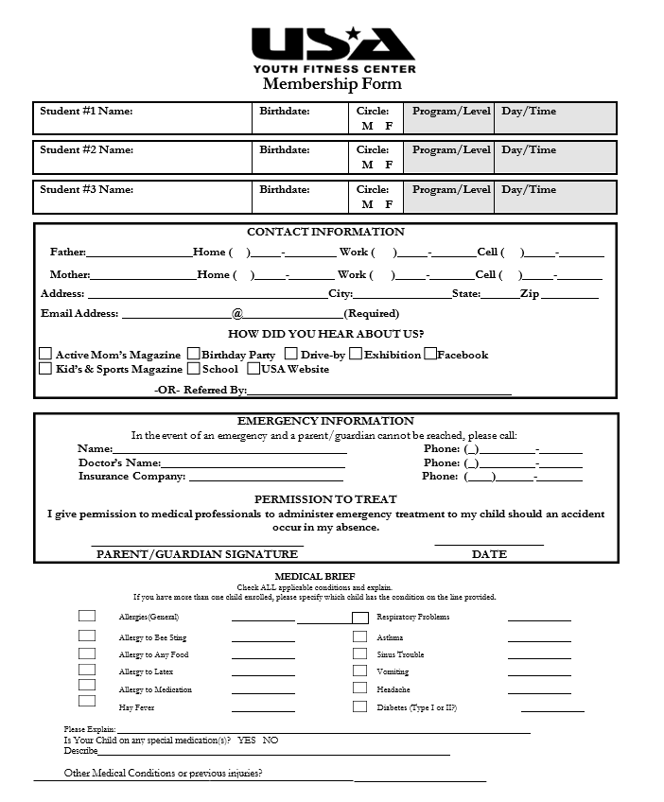

Audition Application
Dancer Bio
(Please Attach Headshot)

Audition Attire:
- Form-fitting Dance Clothes
- All dance shoes – (tap, black crew socks, ballet, hip hop)
- Hair – in a bun (high, low, side – your choice)
Please complete the information below in its entirety.
Incomplete applications will not be accepted.
Dancer’s Full Name
Existing USA Co Dancer | YES NO
Parent Name
Parent Email
Parent Phone
Able to Text?
YES NO

Home Address
City, State, Zip
Age
Birthdate
Years of Dance Experience
Headshot Attached | YES NO

USA Dance Company Parent / Dancer Waiver

This form must be completed to attend Company Auditions.

I (dancer name) ___________________________agree to follow all USA Dance Co. and USA Youth Fitness Center rules and guidelines. I understand the level of commitment asked and understand the attendance rules and requirements. I will always respect my instructors and fellow dancers. I understand that USA Dance Co. is a team, as well as a sport, and my actions affect the entire team.

I fully understand that all fees paid to the gym for my participation in the sport are non-refundable. I fully understand that fees for choreography, camp, uniform, costumes, practice clothes and competition fees will not be refunded even if I leave the team before I have participated in the activity or competed for the company. I fully understand that the uniform is the property of the gym and team members only. If I choose to leave the team before I receive the uniform it will not be given to me, as I would no longer be a team member.

I also understand that the fees will be collected at the time of tuition in the month identified. I give my permission for the fees to be collected on the form of payment I have provided to the gym to secure membership on the company.

Dancer Signature: ______________________________________________
Date: _____________________
Parent Signature: ______________________________________________
I (parent name) ___________________________agree to follow all rules and guidelines for the 2026-2027 season. I will also follow the rules placed through USA Youth Fitness Center. I understand the level of commitment this sport requires and support my dancer. I agree to the fiscal responsibilities placed by USA Youth Fitness Center. I understand that all fees paid are non-refundable. My role as a parent is to support my dancer as well as the USA Dance Company instructors and staff.
Parent Signature: _________________________________________________
Date: ____________________________

USA DANCE COMPANY REFFERAL PROGRAM 2026-2027:
USA XTREME DANCE CO & USA STARS AND STRIPES PERFORMANCE CO
USA is pleased to present the following referral program to all our current USA DANCE team members in the 2026-2027 program! We appreciate knowing that you believe in our program enough to refer it to someone else.

As our way of thanking you for your referral to USA DANCE COMPANY TEAMS, we are offering the following incentive:
1 MONTH OF FREE TUITION FOR EACH QUALIFYING REFERRAL!
The following guidelines apply:
Qualifying Referral: A participant is considered to have joined the team as a referral the first month after they have paid a full month’s tuition to the program.

Both the referring team member and the new team member must sign the referral form the first week the team member joins the program. (Within 7 days of registering.)

The participant cannot be a sibling of the current team member. There is no limit to the number of referrals a current team member can receive.

USA DANCE COMPANY TEAM Referral:

Referred by Name: (the team member name of the person that recommended USA DANCE COMPANY TEAM)

New Member’s Name: Date New Member Joined:
Signatures:

(Referred by Signature and Date): (New Member Signature / Date:

